**Sean Poston**

**CS300 Homework 8**

**27.10:**

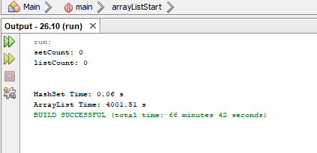

**27.11:**

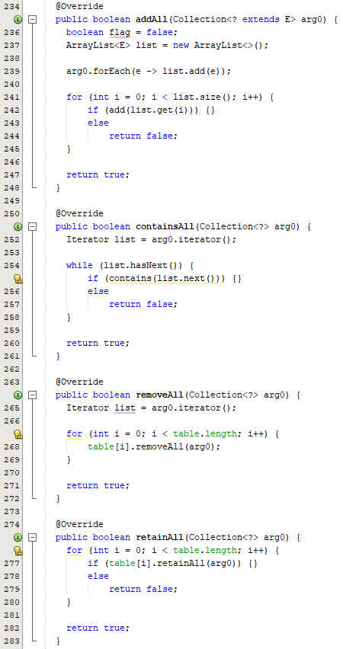

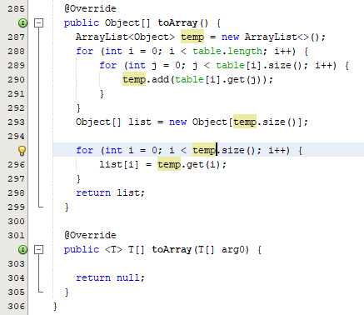

**Source Codes**

**27.10:**

import java.util.ArrayList;

public class Main {

public static void main(String[] args) {

MyHashSet<Double> hashSet = new MyHashSet<>();

MyArrayList<Double> arrayList = new MyArrayList<>();

double randomVar;

int listCount = 0;

int setCount = 0;

for (int i = 0; i < 1000000; i++) {

randomVar = Math.random() * 1000000;

hashSet.add(randomVar);

arrayList.add(randomVar);

}

double[] checkList = new double[1000000];

for (int i = 0; i < 1000000; i++) {

checkList[i] = Math.random() * 2000000;

}

long hashSetStart = System.currentTimeMillis();

for (int i = 0; i < 1000000; i++) {

if (hashSet.contains(checkList[i]))

setCount++;

}

long hashSetTime = System.currentTimeMillis() - hashSetStart;

long arrayListStart = System.currentTimeMillis();

for (int i = 0; i < 1000000; i++) {

if (arrayList.contains(checkList[i]))

listCount++;

}

long arrayListTime = System.currentTimeMillis() - arrayListStart;

System.out.println("setCount: " + setCount + "\nlistCount: " + listCount);

System.out.print("\n\nHashSet Time: "); System.out.printf("%.2f s\n", (double)hashSetTime / 1000.0);

System.out.print("ArrayList Time: "); System.out.printf("%.2f s\n", (double)arrayListTime / 1000.0);

}//end of main function

}//end of main class

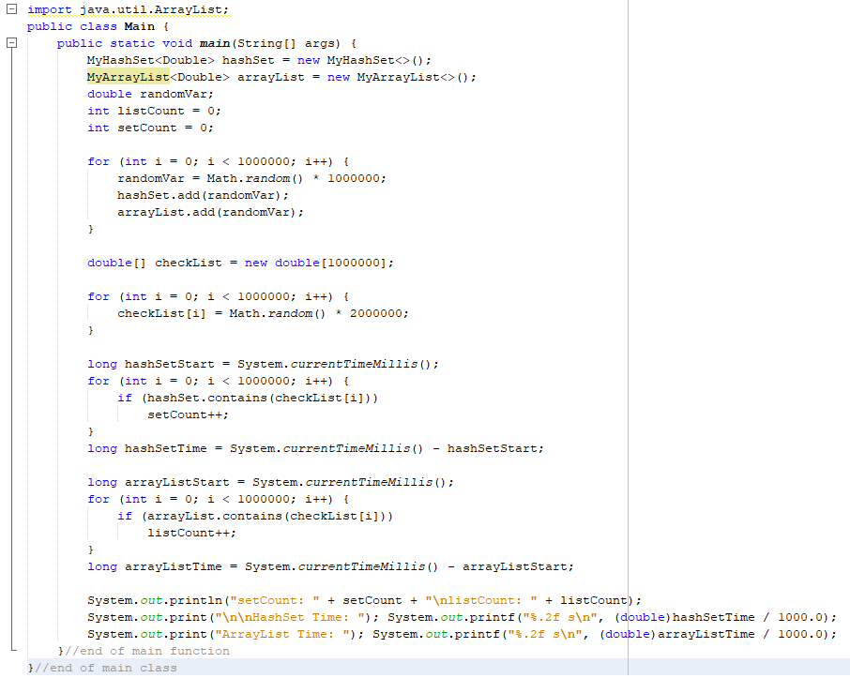

**27.11:**

import java.util.*;

public class MyHashSet<E> implements Collection<E> {

// Define the default hash table size. Must be a power of 2

private final static int DEFAULT_INITIAL_CAPACITY = 4;

// Define the maximum hash table size. 1 << 30 is same as 2^30

private final static int MAXIMUM_CAPACITY = 1 << 30;

// Current hash table capacity. Capacity is a power of 2

private int capacity;

// Define default load factor

private final static float DEFAULT_MAX_LOAD_FACTOR = 0.75f;

// Specify a load factor threshold used in the hash table

private float loadFactorThreshold;

// The number of elements in the set

private int size = 0;

// Hash table is an array with each cell that is a linked list

private LinkedList<E>[] table;

/** Construct a set with the default capacity and load factor */

public MyHashSet() {

this(DEFAULT_INITIAL_CAPACITY, DEFAULT_MAX_LOAD_FACTOR);

}

/** Construct a set with the specified initial capacity and

* default load factor */

public MyHashSet(int initialCapacity) {

this(initialCapacity, DEFAULT_MAX_LOAD_FACTOR);

}

/** Construct a set with the specified initial capacity

* and load factor */

public MyHashSet(int initialCapacity, float loadFactorThreshold) {

if (initialCapacity > MAXIMUM_CAPACITY)

this.capacity = MAXIMUM_CAPACITY;

else

this.capacity = trimToPowerOf2(initialCapacity);

this.loadFactorThreshold = loadFactorThreshold;

table = new LinkedList[capacity];

}

public MyHashSet(E[] list) {

this();

for (int i = 0; i < list.length; i++) {

add(list[i]);

}

}

@Override /** Remove all elements from this set */

public void clear() {

size = 0;

removeElements();

}

@Override /** Return true if the element is in the set */

public boolean contains(Object e) {

int bucketIndex = hash(e.hashCode());

if (table[bucketIndex] != null) {

LinkedList<E> bucket = table[bucketIndex];

return bucket.contains(e);

}

return false;

}

@Override /** Add an element to the set */

public boolean add(E e) {

if (contains(e)) // Duplicate element not stored

return false;

if (size + 1 > capacity * loadFactorThreshold) {

if (capacity == MAXIMUM_CAPACITY)

throw new RuntimeException("Exceeding maximum capacity");

rehash();

}

int bucketIndex = hash(e.hashCode());

// Create a linked list for the bucket if it is not created

if (table[bucketIndex] == null) {

table[bucketIndex] = new LinkedList<E>();

}

// Add e to hashTable[index]

table[bucketIndex].add(e);

size++; // Increase size

return true;

}

@Override /** Remove the element from the set */

public boolean remove(Object e) {

if (!contains(e))

return false;

int bucketIndex = hash(e.hashCode());

// Create a linked list for the bucket if it is not created

if (table[bucketIndex] != null) {

LinkedList<E> bucket = table[bucketIndex];

bucket.remove(e);

}

size--; // Decrease size

return true;

}

@Override /** Return true if the set contains no elements */

public boolean isEmpty() {

return size == 0;

}

@Override /** Return the number of elements in the set */

public int size() {

return size;

}

@Override /** Return an iterator for the elements in this set */

public java.util.Iterator<E> iterator() {

return new MyHashSetIterator(this);

}

/** Inner class for iterator */

private class MyHashSetIterator implements java.util.Iterator<E> {

// Store the elements in a list

private java.util.ArrayList<E> list;

private int current = 0; // Point to the current element in list

private MyHashSet<E> set;

/** Create a list from the set */

public MyHashSetIterator(MyHashSet<E> set) {

this.set = set;

list = setToList();

}

@Override /** Next element for traversing? */

public boolean hasNext() {

return current < list.size();

}

@Override /** Get current element and move cursor to the next */

public E next() {

return list.get(current++);

}

@Override /** Remove the element returned by the last next() */

public void remove() {

// Left as an exercise

// You need to remove the element from the set

// You also need to remove it from the list

}

}

/** Hash function */

private int hash(int hashCode) {

return hashCode & (capacity - 1);

}

/** Return a power of 2 for initialCapacity */

private int trimToPowerOf2(int initialCapacity) {

int capacity = 1;

while (capacity < initialCapacity) {

capacity <<= 1;

}

return capacity;

}

/** Remove all e from each bucket */

private void removeElements() {

for (int i = 0; i < capacity; i++) {

if (table[i] != null) {

table[i].clear();

}

}

}

/** Rehash the set */

private void rehash() {

java.util.ArrayList<E> list = setToList(); // Copy to a list

capacity <<= 1; // Double capacity

table = new LinkedList[capacity]; // Create a new hash table

size = 0; // Reset size

for (E element: list) {

add(element); // Add from the old table to the new table

}

}

/** Copy elements in the hash set to an array list */

private java.util.ArrayList<E> setToList() {

java.util.ArrayList<E> list = new java.util.ArrayList<>();

for (int i = 0; i < capacity; i++) {

if (table[i] != null) {

for (E e: table[i]) {

list.add(e);

}

}

}

return list;

}

@Override

public String toString() {

java.util.ArrayList<E> list = setToList();

StringBuilder builder = new StringBuilder("[");

// Add the elements except the last one to the string builder

for (int i = 0; i < list.size() - 1; i++) {

builder.append(list.get(i) + ", ");

}

// Add the last element in the list to the string builder

if (list.size() == 0)

builder.append("]");

else

builder.append(list.get(list.size() - 1) + "]");

return builder.toString();

}

@Override

public boolean addAll(Collection<? extends E> arg0) {

boolean flag = false;

ArrayList<E> list = new ArrayList<>();

arg0.forEach(e -> list.add(e));

for (int i = 0; i < list.size(); i++) {

if (add(list.get(i))) {}

else

return false;

}

return true;

}

@Override

public boolean containsAll(Collection<?> arg0) {

Iterator list = arg0.iterator();

while (list.hasNext()) {

if (contains(list.next())) {}

else

return false;

}

return true;

}

@Override

public boolean removeAll(Collection<?> arg0) {

Iterator list = arg0.iterator();

for (int i = 0; i < table.length; i++) {

table[i].removeAll(arg0);

}

return true;

}

@Override

public boolean retainAll(Collection<?> arg0) {

for (int i = 0; i < table.length; i++) {

if (table[i].retainAll(arg0)) {}

else

return false;

}

return true;

}

@Override

public Object[] toArray() {

ArrayList<Object> temp = new ArrayList<>();

for (int i = 0; i < table.length; i++) {

for (int j = 0; j < table[i].size(); i++) {

temp.add(table[i].get(j));

}

}

Object[] list = new Object[temp.size()];

for (int i = 0; i < temp.size(); i++) {

list[i] = temp.get(i);

}

return list;

}

@Override

public <T> T[] toArray(T[] arg0) {

return null;

}

}